Machine Description | A deliberately vulnerable lab machine for practicing web app exploits, privilege escalation, and post-exploitation to gain user and root access.
Target IP | 192.168.0.119
Vulnerability Name | - Drupal CMS Remote Code Execution.  - SUID Misconfiguration.
Port / Service | http 80 /drupal
Severity | 8.4 high
Attack Vetor | CVSS:3.0/AV:L/AC:L/PR:N/UI:N/S:U/C:H/I:H/A:H
Proof of Concept (PoC) | STEP 1 – Nmap to find the IP of the target machine.  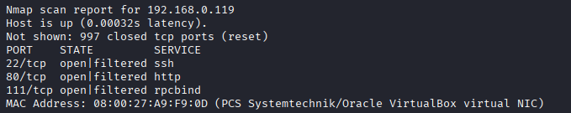  STEP 2 – Nmap Scan to discover open ports and Services  # nmap –p- -sC –sV $ip –open  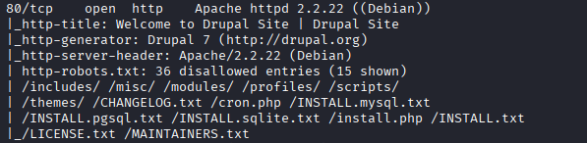  Step 3-We found out possible versions of Durpal using droopescan  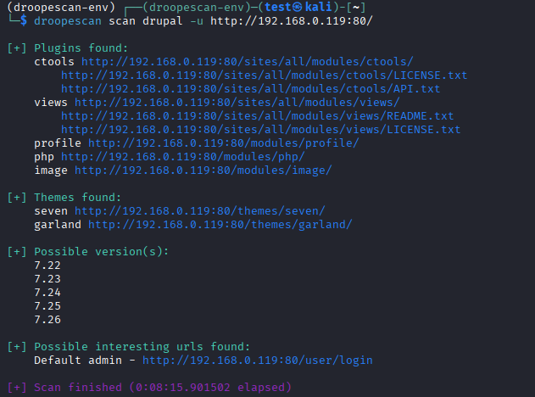  Step 4-search for sploit in metaspolit  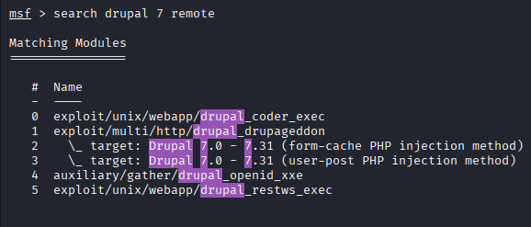  Step 5- We are using 1  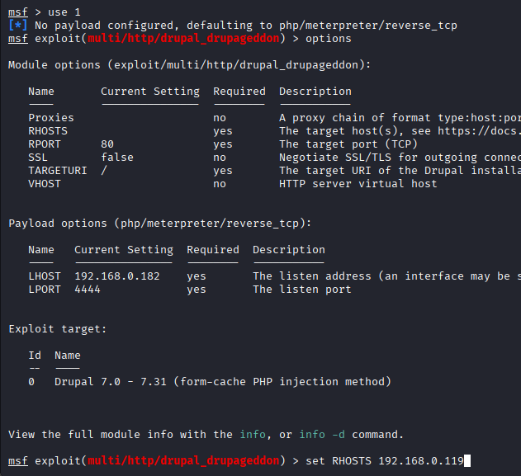  Step 6-Run the exploit, we have a shell.  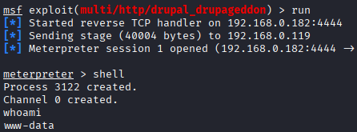  Step 7-We found that the find cmd has the SUID permissions.  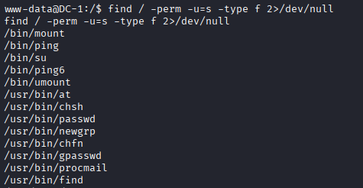  Step 7- We can use it to get root.  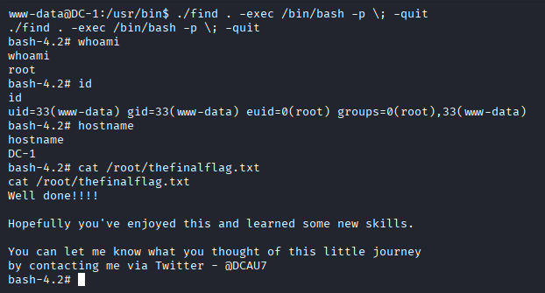
Remediation | - Update Drupal to the latest secure version immediately.  - Apply all official Drupal security patches.  - Restrict access to the admin panel using strong passwords and MFA.  - Regularly scan the CMS for outdated plugins or modules.  - Remove SUID permission from unsafe binaries
Impact | - An attacker can completely take over the website.  - They can run any command on the server (like installing malware or stealing data).  - Leads to full system compromise.
References | https://www.acunetix.com/blog/web-security-zone/drupalgeddon2/  https://www.hackingarticles.in/linux-privilege-escalation-using-suid-binaries/

